1. Create a query to display the employee last name and department number

for employee number 176.

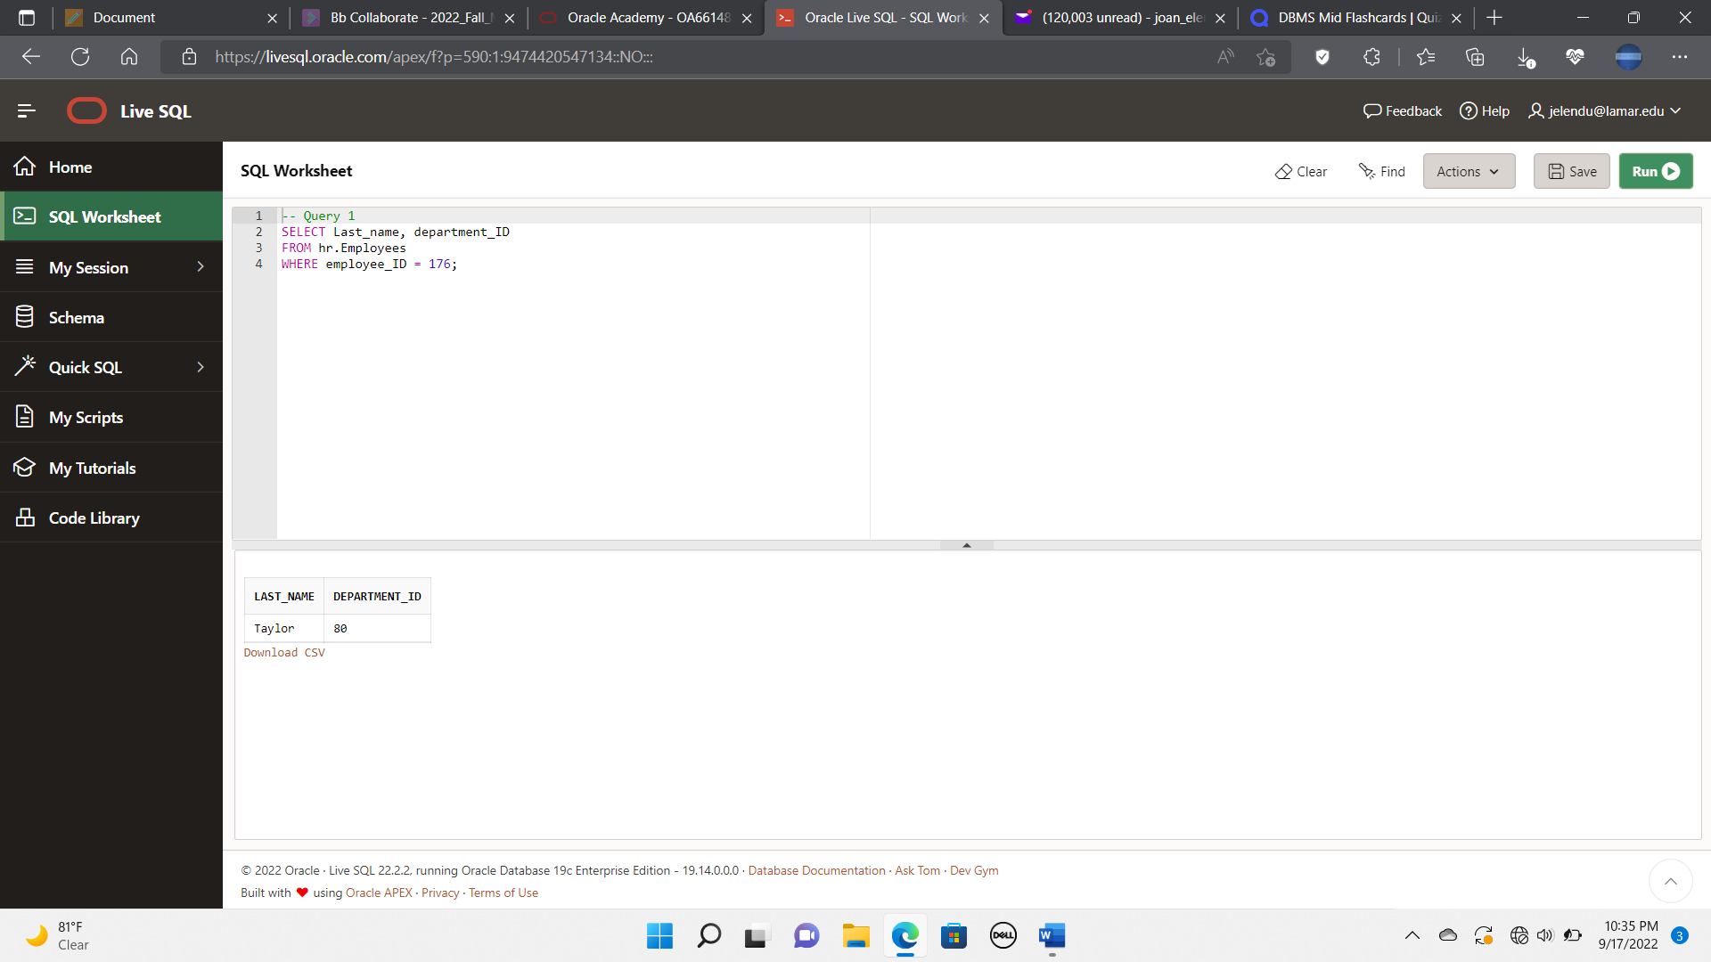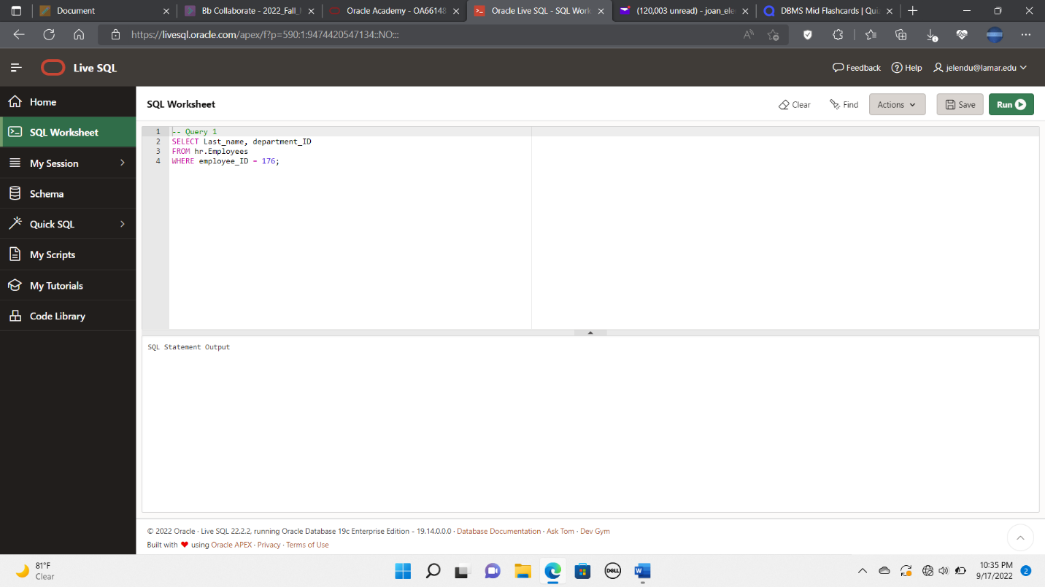

2. Create a query to display employee number, last name, first name, job code,

hire date, and salary from the EMPLOYEES table. Separate each column by

a comma and space. Name the column THE_OUTPUT.

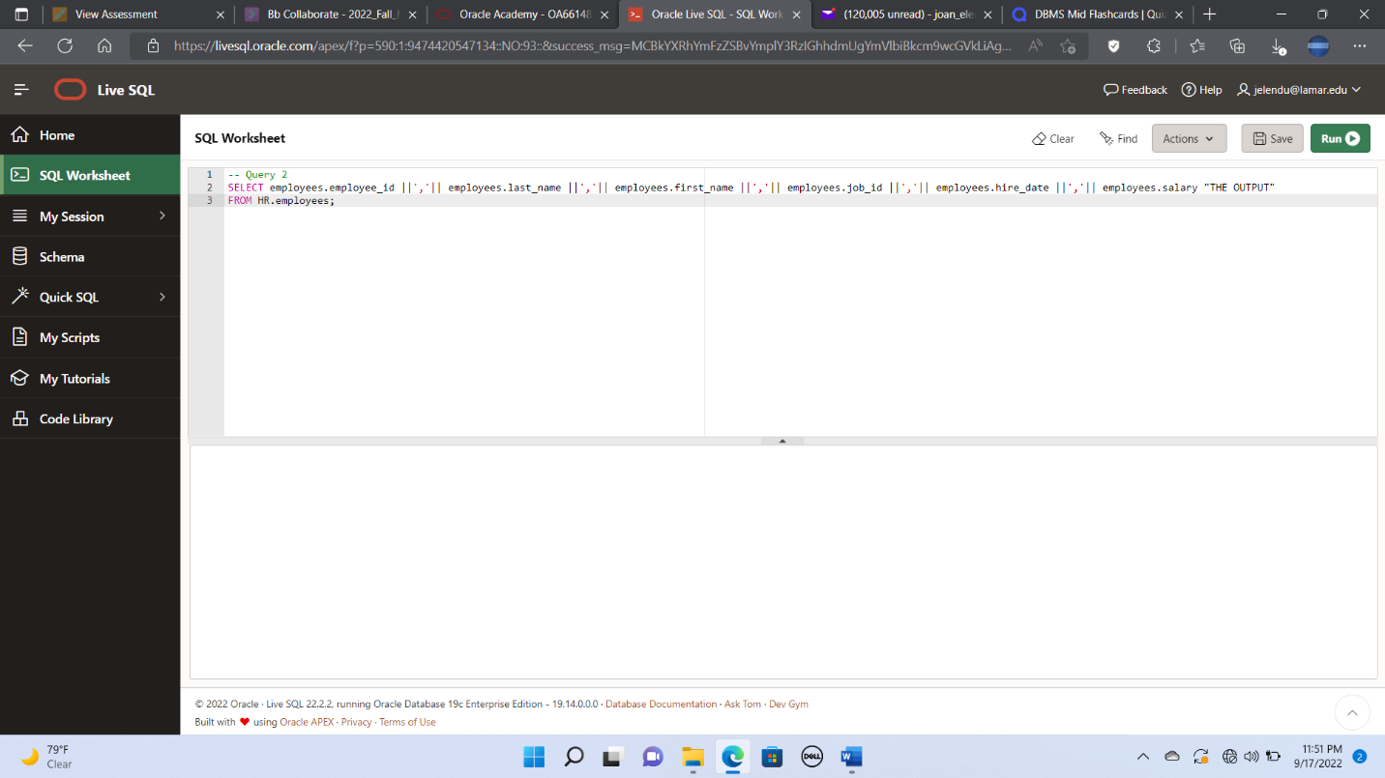

3. Create a query to display the employee last name, job ID, and start date of

employees hired between February 20, 2005, and May 1, 2005. Order the

query in ascending order by start date.

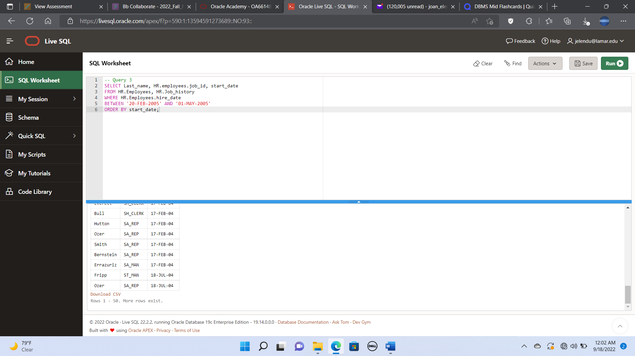

4. Create a query that will list the last name and salary of employees who earn

between $5,000 and $12,000 and are in department 20 or 50. Label the

columns Employee and Monthly Salary, respectively.

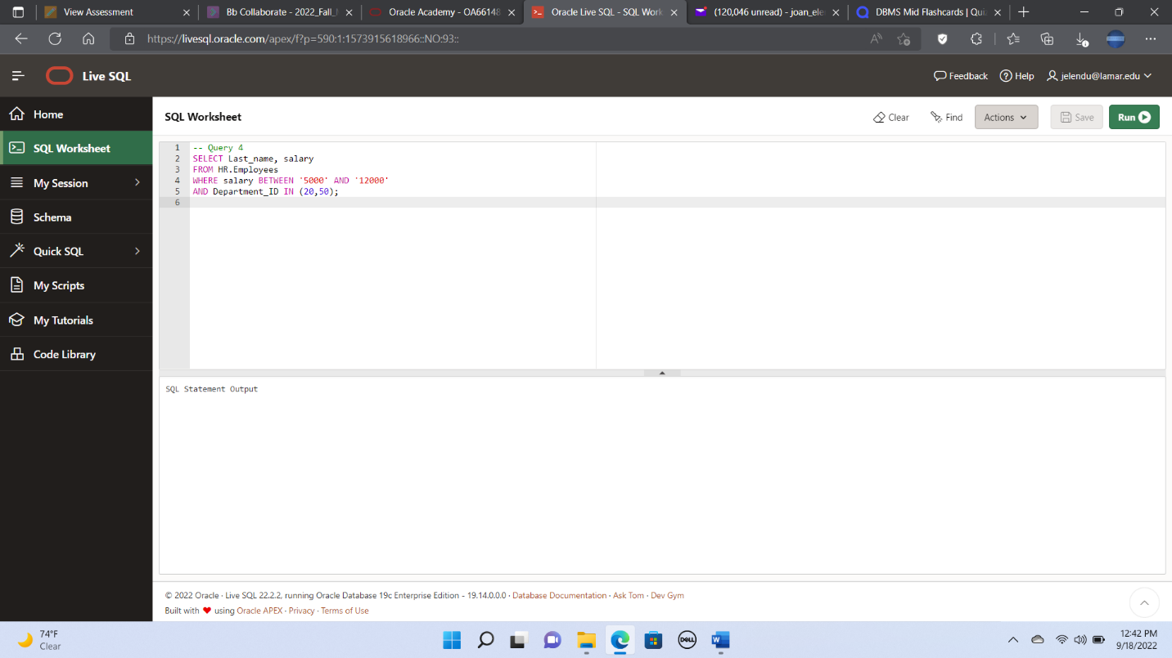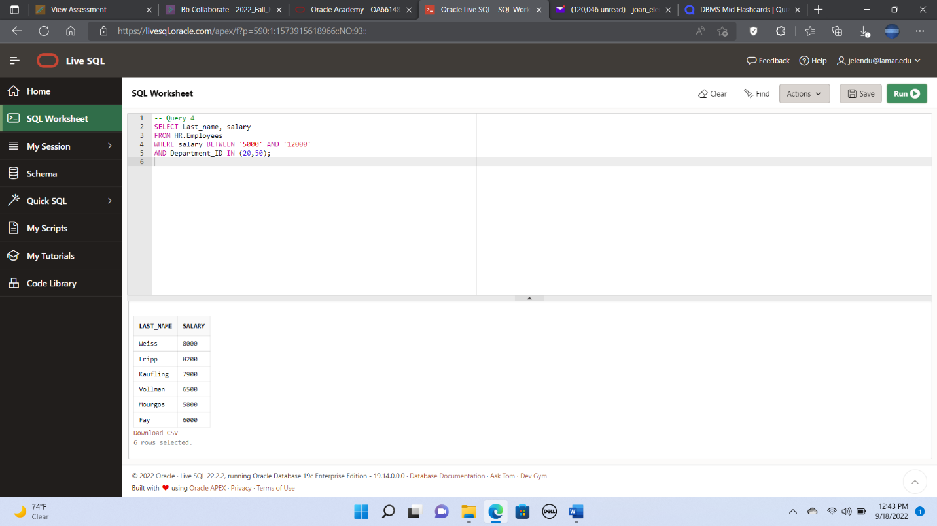

5. Create a query to display the last name and job titles of all employees who

do not have a manager.

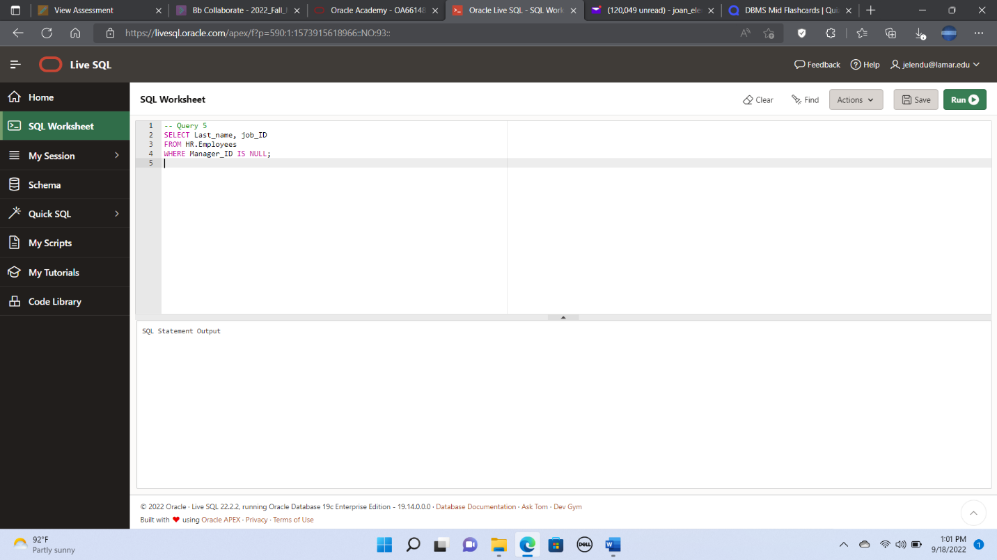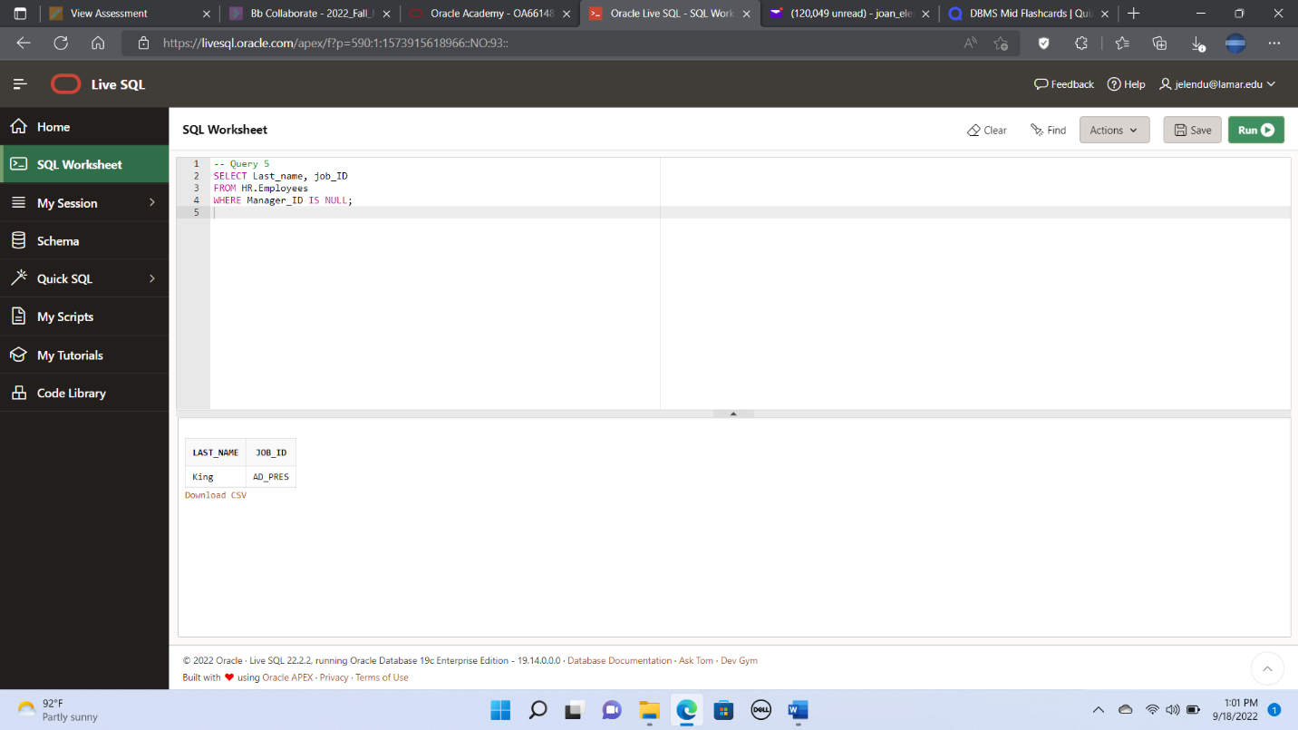

6. Create a query to display the last names of all employees where the third

letter of the name is an **a.**

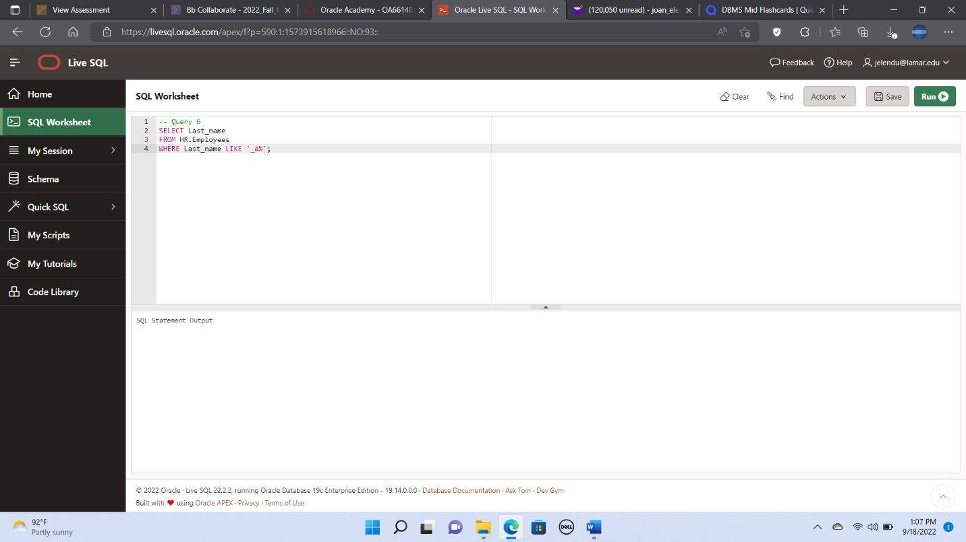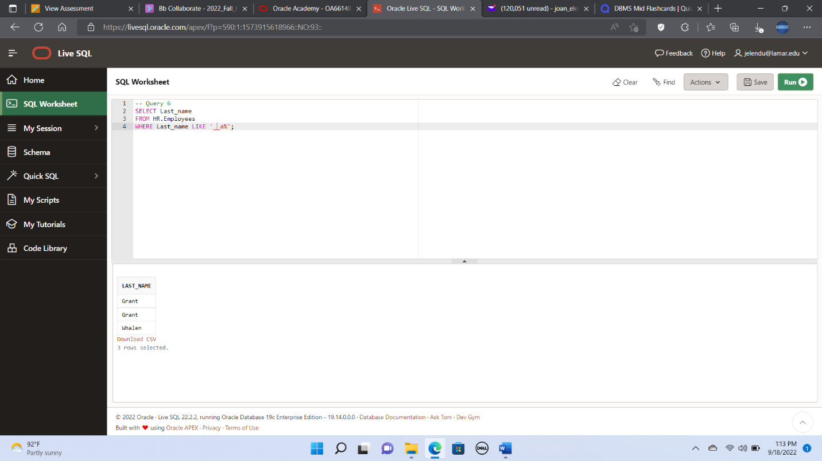

7. Create a query to display the last name, job, and salary for all employees

whose job is sales representative or stock clerk and whose salary is not

equal to $2,500, $3,500, or $7,000.

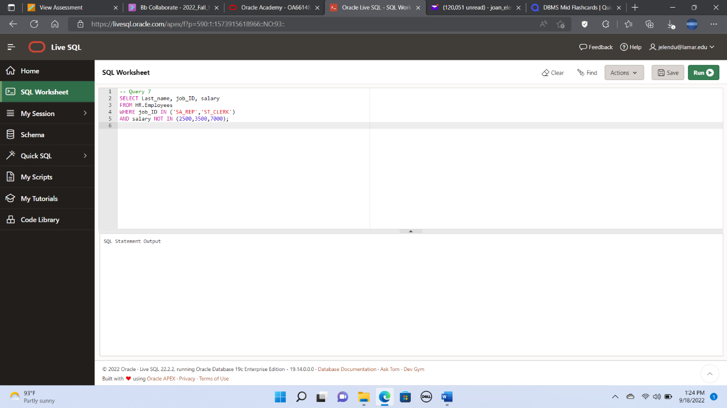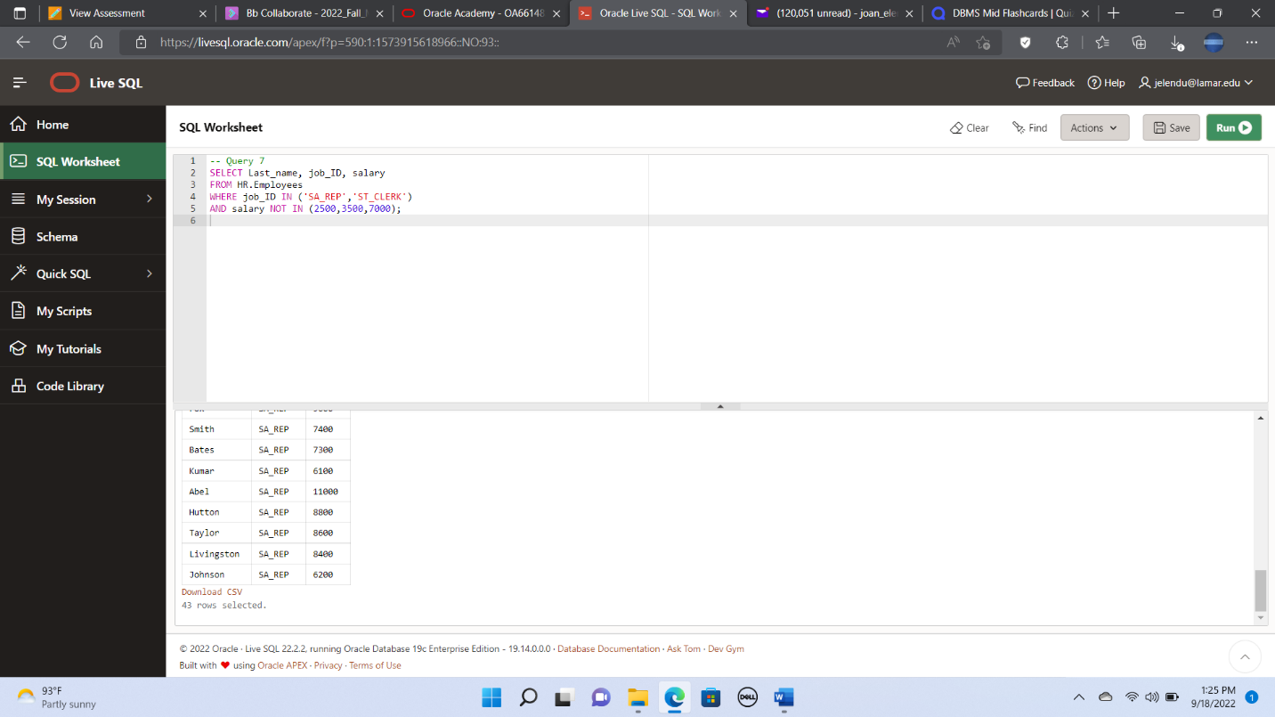

8. Create a query that will display the employee number, last name, salary, and

salary increased by 15% and expressed as a whole number for each

employee. Label the new column New Salary. Add a column that subtracts

the old salary from the new salary. Label the column Increase.

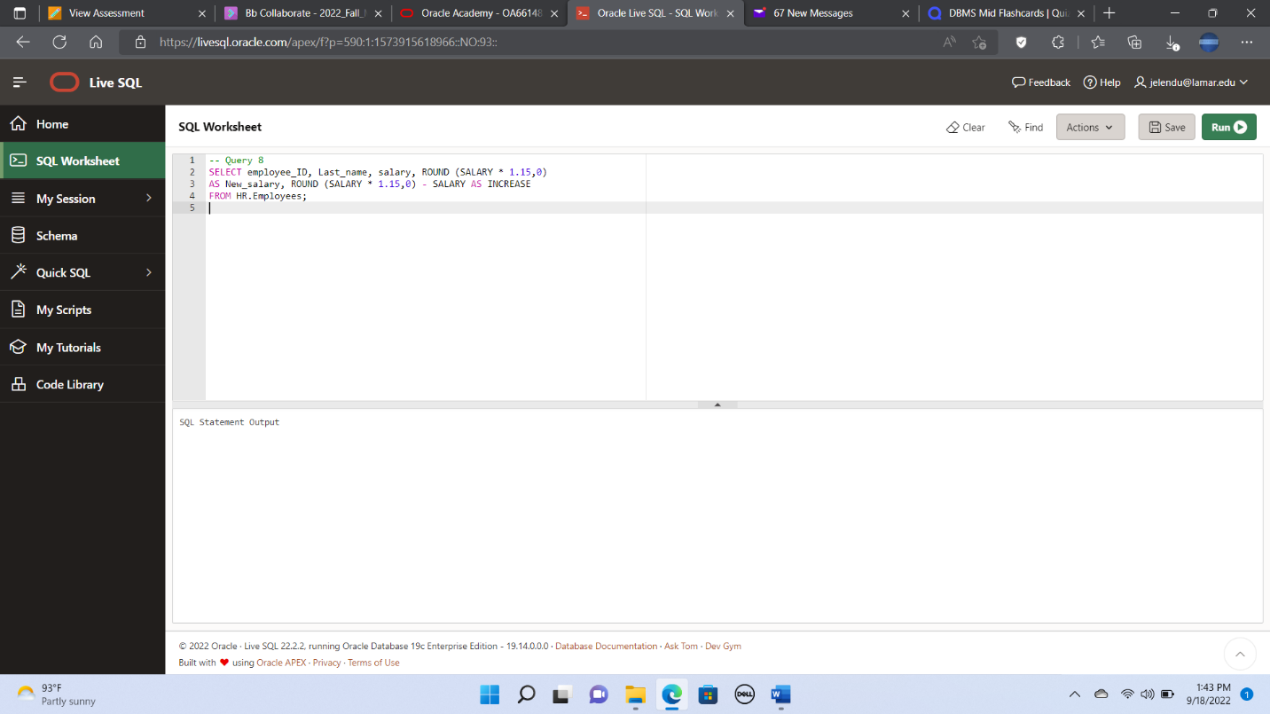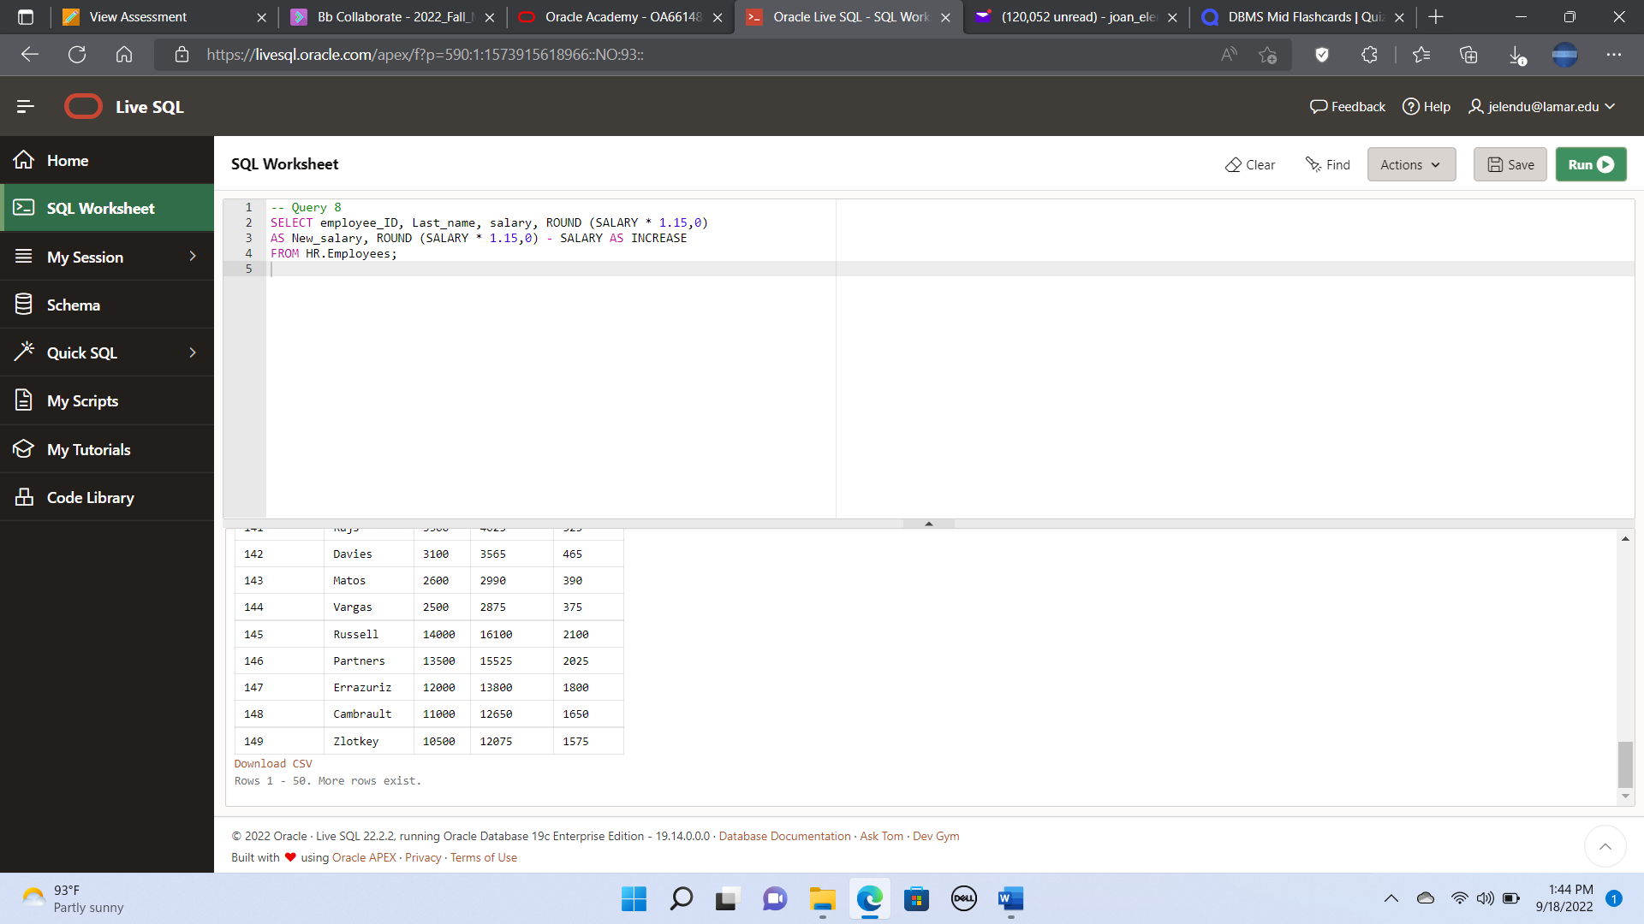

9. Create a query to display the employee last name, department name,

location ID, and city of all employees who earn a commission.

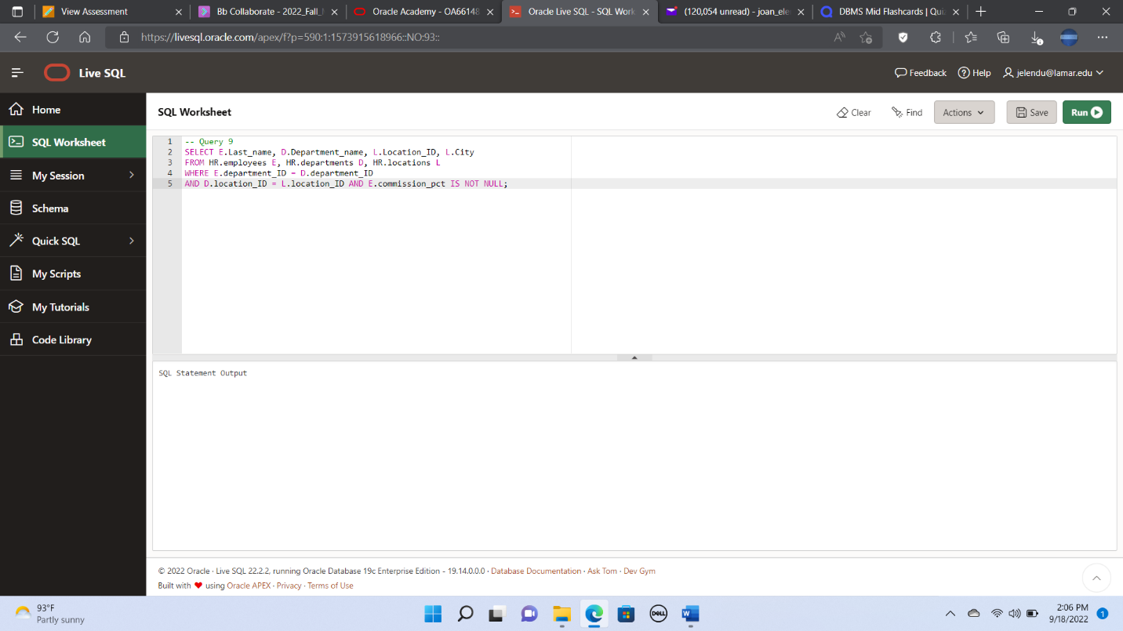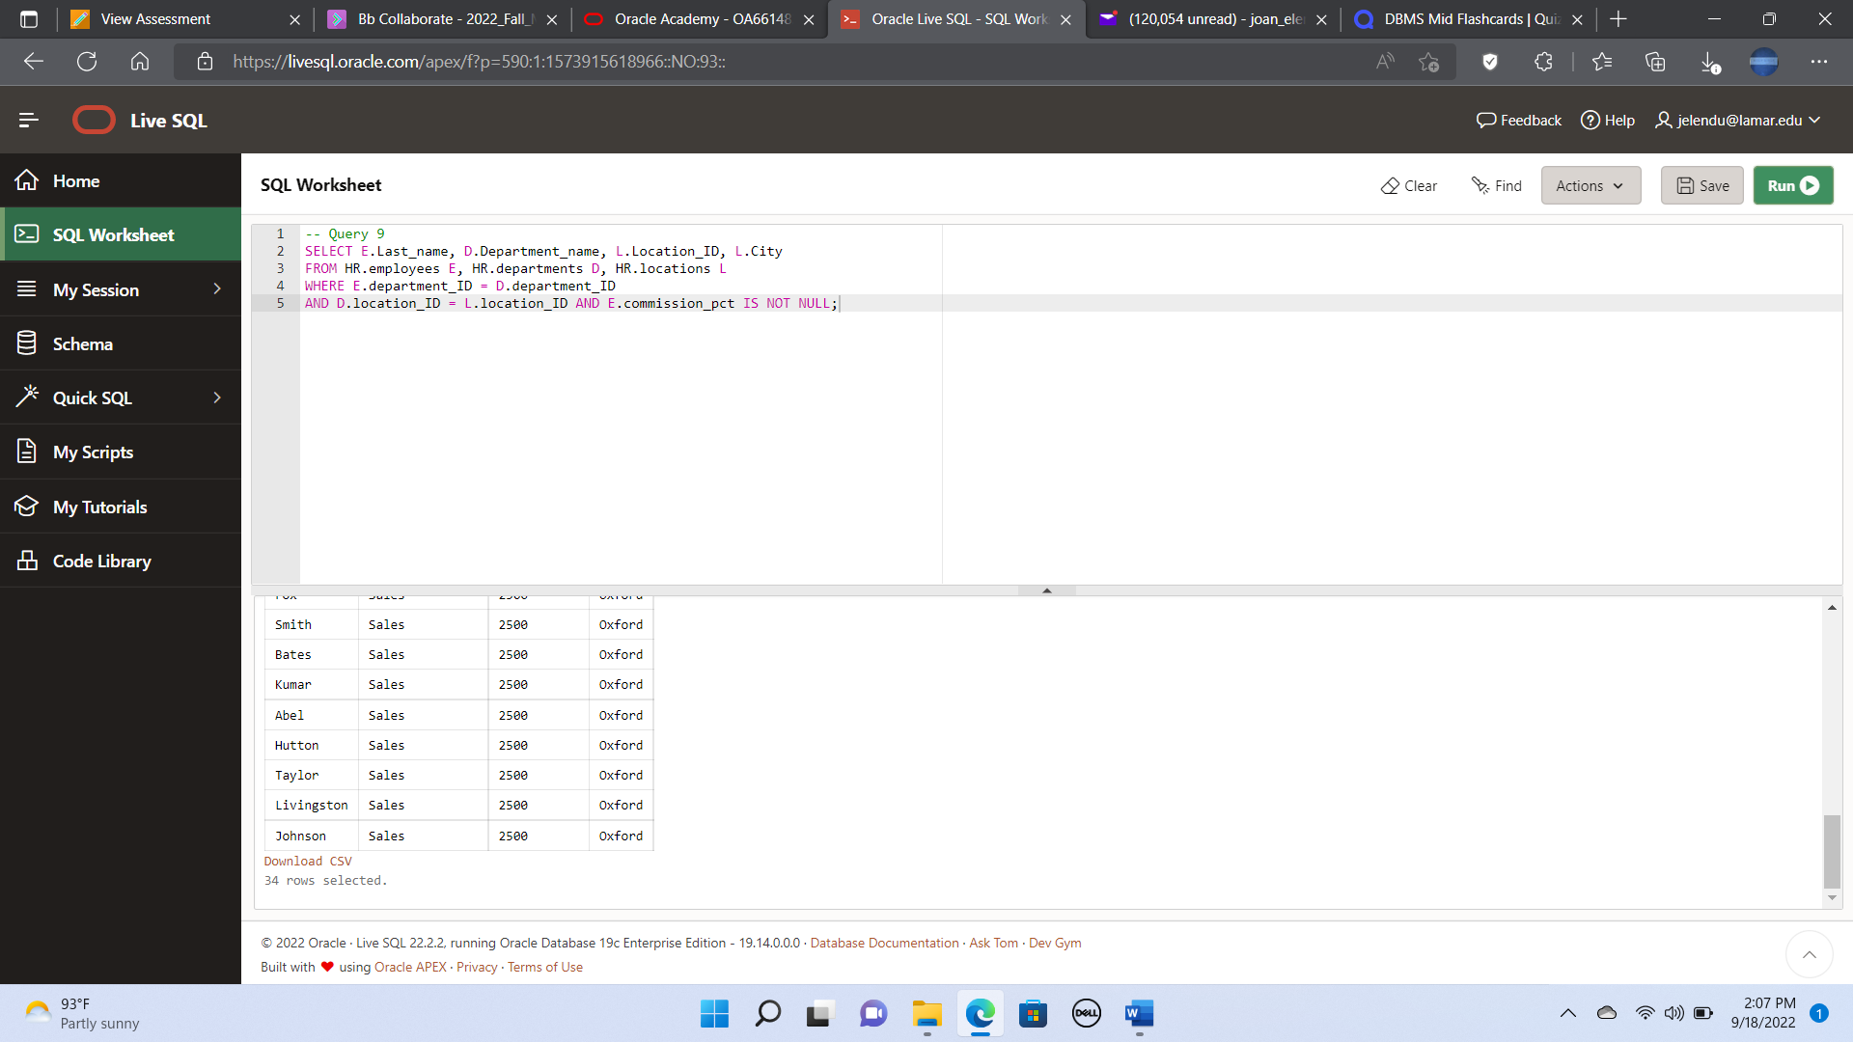

10. Create a query that displays the employees’ last names and commission

amounts. If an employee does not earn a commission, put “No

Commission.” Label the column COMM.

